Andrew Lane

Group #1

As of 8/11/16

**Journal Entry #14 8/7/16 – 8/11/16**

The last week of our final sprint was a doozy! We spent a significant amount of time meeting online, squashing bugs, and burning the midnight oil! I hated getting rid of my MEAN webapp, but I did enjoy learning PHP (even though it’s a dying technology). The main issues I faced this week was:

1. Merging everyone’s changes – There were so many changes. Mostly because of my refactoring/restructuring last week, but also because I decided to bootstrap each page (because they looked terrible).
2. Fixing file paths – Icarus just serves everything, there’s no routing (like a typical LAMP website), so these merges brought many issues.
3. Nate and I fixing people’s code – My group enjoyed pushing code that didn’t work (aside from Nate and Andre), even directly to master. Fixing someone else’s code is never ideal.

Overall I learned that I hate group work. In the past, I could always depend on other group members. All of that changed with this project. I could’ve made a much better application all by myself given the allotted time. Although I did learn a valuable lesson – It’s not just about what’s best for one person, it’s about what’s best for the entire team.

**Journal Entry #13 7/32 – 8/6/16**

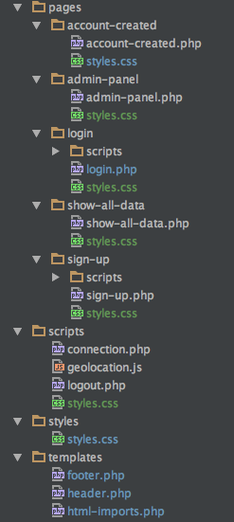This week was interesting – I learned PHP, did some refactoring, Gulpified the project and added a deploy script. The codebase was poorly organized so I decided to organize it on a page by page basis. Each page directory contains all related styling, pages, and scripts. All the common scripts, styles and templates are located in their respective directories in the project root. The Gulp tasks I wrote are pretty cool. Running the “gulp dev” task watches all files in the project. When any file is changed, gulp lints the entire project. If the linting passes, my deploy script kicks in and deploys to our server (Icarus). Deploy parameters are stored in environment variables.

Refactored Directory Structure

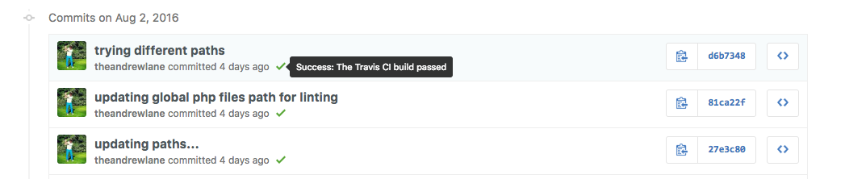I also integrated with a new Travis CI build server. The process I described above is followed on the build server after every commit (aside from the watching part). If there is a deploy problem (or linting) an email will be sent to the person who broke the build. In order to merge pull requests the build must pass, also each commit has a build status indication (which is pretty awesome!).

Unfortunately, no one understands what I’ve done (I wish there were more prerequisites to get into this class!!!), even though I detailed everything when I updated the readme.md. Aside from that, our team meetings keep getting pushed back because no one can make the times fit into their schedule. This group project has really changed my whole perspective on group work.

**Journal Entry #12 7/24 – 7/30**

I don’t really have too much to report this week, I’ve kind of just been keeping my mouth shut lately. I’m no expert in PHP, but I do know a thing or two about building webapps – What we currently have is not cohesive, modular, or a properly designed architecture, and it’s only going to get worse. Fortunately, my team has not given me and difficult tasks for this last sprint, I’m just putting together the main/landing page. I’ve also opted to create some stored procedures on the MySQL database side (so we don’t have to query the DB statically in PHP). PHP is a pretty easy language to build websites with I’m enjoying this so far, however AngularJS and NodeJS are far superior alternatives!

**Journal Entry #11 7/16 – 7/23**

Well this week was interesting. The team decided to ditch my code, design, integration pipeline, and framework in favor of a basic PHP + MySQL website. Their reasoning was that the MEAN framework (specifically AngularJS) was too complex to learn (even though they have literally had WEEKS to learn it), especially on top of learning Git (is Git really that hard to learn?). I spent 20+ hours on everything by myself, and even though I explained everything I did, I don’t think my team will never realize the work and planning this project consumed. My website was awesome, the framework was modern and relevant, the project structure was logical and well-rounded, everything was scalable and could be easily deployed Perhaps the team never noticed this because they never contributed to anything.

We had a Google Hangouts meeting this week to talk about the new PHP design and strategies, and I decided it would be best that I just keep my mouth shut because the team does not agree with me, and I was growing tired of trying to back up my points. Rather than using Git, the team has chosen to use an FTP application to move files from their computer to Icarus, where we are hosting our website. Rather than creating an API layer or even stored procedures on the Icarus hosted MySQL instance, we plan to write the queries in directly in the PHP. Rather than using some sort of web development IDE (IDEA Webstorm is awesome) it was recommended that we all use Notepad++ (not necessarily bad, but there are so many better options out there!!). Lastly, there were no best practices layout out, no project structure defined, and no concurrent development strategy. In my eyes, the only thing that was done right was the ERD for the MySql database… My favorite part of this meeting however was that I was asked to demo MY website for the deliverable on Tuesday (which I’m kind of bitter about, for obvious reasons) - only if the team didn’t make enough progress on the website this weekend. I love group work.

**Journal Entry #10 7/10 – 7/16**

I don’t have very much to report this week; however, I did accomplish a few things. I got the team a Travis CI server to build and test our website. This sever has been configured to build our website after every code commit. In order to merge code into the develop branch, the Travis CI build must pass within a pull request. I also created a Gitter chatroom so the team could talk about code in a centralized location. Now that these to integrations have been added to our pipeline, we have cool badges on our readme.md page!

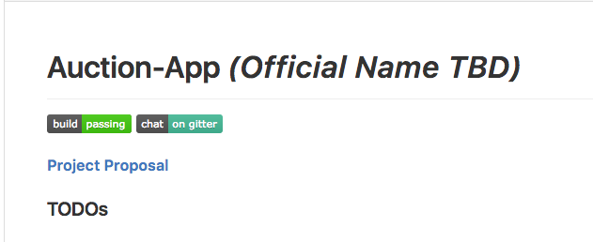

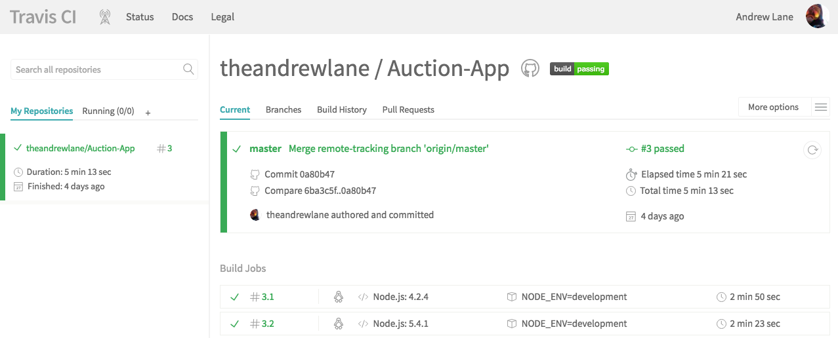

**Journal Entry #9 7/2 – 7/9**

This week, again, I single handedly lead development and scrum efforts. Out of the 36 commits to our repository, 34 of them are mine (the 2 others were from Nate). I was able to accomplish several things. The most notable achievement this week was setting up a [website](https://auctions-near-me.herokuapp.com/) to host our app - I created a Gulp deploy task to make the process effortless. I also set up a remote MongoDB instance for the team. I have no issues running/hosting MongoDB locally (because I’m on a Mac!), but the rest of the team (Windows users) has been struggling. Anyway, I created a new Gulp build task that connects the Dev environment to my remote DB rather than looking for a local instance.

In an effort to increase the usability of my dev environment, I managed to pack everything into a Docker container. My other teammates (Windows users) had trouble with dependencies (wrong versions installed, missing components and global node modules, etc..), and I burned a lot of time troubleshooting their machines. My Docker container eliminates any and all errors related to getting a dev environment up and running

Lastly, I outlined a development process for the team:

* The master branch should contain the latest production code (we don’t have this yet obviously).
* The develop branch should only contain completed and working story/task work.
* When starting a new Jira story/task, the developer should create a new branch off develop:
  + *feature/<JIRA story/task number>-brief-branch-description*
* Feature branches are merged to develop only by a pull request, which requires approval from all team members.

I killed it this week, and I don’t think my team even knows what I’ve done. I love group work.

**Journal Entry #7 6/19 – 6/25**

This week I got my development environment (Mongo, Node, Express, Gulp) running on everyone’s machine (except Jeremy’s). I spent time with everyone during class and walked them through the setup. During this time I was getting annoyed with Jeremy - he’s not taking anything we’re doing seriously. While I was answering everyone’s questions he’d be playing loud YouTube videos or talking about Lord of the Rings. There was one point where he interrupted us with a 20 second “evil laugh” and proceeded to tell us he could laugh like that any time he wanted. Aside from that, we got our first sprint planned even though our Scrum master couldn’t make it.

This next week, I plan to create a Gulp deploy task (to Heroku or Amazon EC2) and sync everything up with a hosted MongoDB somewhere! I plan on stepping back for a little while so the rest of the team can contribute something, I don’t like having the feeling that I’ve done everything an they’ve done nothing. During this time, I plan on brushing up on my AngularJS skills.

**Journal Entry #6 6/12 – 6/18**

I did a lot of development work this week. I created a login page, an account creation page, a landing page, and an auction page. All of these pages utilize a Mongo DB backend. The rest of my group has done nothing! I’m planning on sitting back this next and letting them get some work done, I don’t want to do this entire project by myself.

**Journal Entry #5 6/5 – 6/11**

This week was pretty uneventful for my project. I created an epic and a few stories in Jira around UI design and the account creation process. I also created a Github website (mostly a placeholder) for the team app. The team and I briefly did some storyboarding after class on Thursday, and I also answered some technical questions.

The project charter is due today (Saturday) and the group leader told me I didn’t have to contribute to this assignment because I’ve already put in a lot more work on the project than anyone else. I really enjoy being on team where my technical opinions and standpoints are trusted and respected, although it kind of worries me because I don’t want to build and architect this app all by myself!

**Journal Entry #4 5/27 – 6/4**

My group and I are finally starting to get somewhere with our application. After a lot of research I decided to use the MEAN stack (MongoDB, Express, AngularJS, NodeJS) for development, Gulp for build tasks, and Amazon EC2 for hosting (pushed via Gulp task). I suggested this stack, and no one disagreed – I guess that means they’re: 1. Scared to disagree with me. 2. Think I’m really smart and will agree with whatever I think is best. 3. Don’t have any arguments to make because they’re not familiar with MEAN and Gulp. Anyway, I created a team Github repo and deployed some code and instructions! I guess we’ll see what happens ☺

As far as the tools presentation is concerned, mine is done! I came up with the idea, wrote the entire script, recorded the entire video by myself… My partner was mad at me when he couldn’t get it to run, even though the instructions were clearly written in my Github repo! When trying to upload the presentation to YouTube, I got flagged for copyright infringement for something at the end of the demo (The RickRoll song, haha)!

**Journal Entry #3 5/21 – 5/26**

Okay, this is my third journal entry and things are starting to get a little more interesting! We’ve finally decided on a group project, and we’re going with my idea! This week we’ve been brainstorming features. I got our team a cloud server, and set up a MongoDB backend. I also stood up an Asanna instance for the team, however I was really hoping to get my hands on Jira. Asanna isn’t nearly as functional. Finally, I set up a private Github repo for all of our code!

The tools presentation is complete, I put together a pretty cool docker demo! I’m just finishing up the editing, and Patrick is rehearsing! Our presentation should be pretty cool!

**Journal Entry #2 5/16 – 5/20**

This is my second journal entry, so here it goes… Still nothing too exciting has happened. My group decided on the teacher app from last week, despite my urge to go a more sensible direction. I told them I have 5 years of experience in the software industry (which I actually do!), but for some reason it doesn’t seem like they value my opinions/thoughts more than anyone else. I don’t know how, but they think this app can be finished before the semester ends. I would think anyone would prefer working on something that we could finish, and in turn display it on our resumes!

In regards to the tools presentation, things are on track! Patrick and I have evenly divided up the work load, and I’ve had a lot of fun playing around with Docker! I’m really excited for our presentations; I have a feeling it will be one of the best ones (or at least the most interesting) in the entire class!

**Journal Entry #1 5/9 – 5/13**

Okay, so this is my first journal entry. It is also the first completed week of the semester. Nothing too exciting has happened. I met my team however – They’re quite interesting, especially one of the team members who kept screaming that he wanted to create a computer virus and take down the internet. Everyone else wants to work on a student/teacher learning app, while I’d rather put our time and energy into a live bidding app for charity auctions or perhaps an online price comparison tool. I’m a little worried at this point. I know I have the most real world software development experience in the class, and no one on my team seems to know that or respect my personal opinion. The project my team wants to work on is a dumb idea, and technically difficult. Too bad there’s nothing I can do to change that.

This next week I intend to accomplish the first step of the tools project – build a Docker container, play around with it, and show it to Ted. As for the project, I intend to make the group switch to a better idea. Literally anything else. Weekly journal entries are a way for you to reflect on your progress in this class and your experience with your customer while the thoughts are fresh in your mind.